

youRJube

Overview

**youRJube** is a company that focuses on **video sharing** from **content creator**, the company also focuses to give a lot of **video category** to the user to bring entertainment from **every platform**.

The project manager, Rafael wants you to create a website that support **non-Latin characters** in all pages. Inspired from his senior IVeh who is kind of person that often curious about why people do something. Rafael expected you to always **know** the **reason** behind **what you are doing**. In this project, Rafael wants you to use **Git** version control system so that he could monitor the progress by seeing your commit every day. You could use either **GitHub** or **GitLab** for your repository, even though it is suggested to use **GitLab** for the git repository manager. Make sure your repository for this project is set to **private** so that nobody could steal your work. Rafael also takes interest in his senior IVeh who really **hates** people that **doesn’t** uphold their **integrity**! So, make sure when you are presenting the result to Rafael, you are presenting what you had done until **last commit** before **deadline**.

In this project, you are asked to use **GoLang** as the backend language that will be used for creating **GraphQL API**, followed by **Angular2** as the frontend framework to develop your application. The language you must use for the angular framework is **Typescript**. To make sure the web service called GraphQL, your API endpoint must be accessible by using **public IP/domain**. For the database, you are asked to use **PostgreSQL**. You are free to use the databases in any section, but you must have **logical** and **strong reason** why you use it there.

There’re some factors that you should notice such as **performance**, **design**, **security** and **tools understanding**.

In the performance factor, you are asked to use **Redis** to **cache** the result of any API data you consume. You are asked to use **RxJS** javascript library to help you deals with asynchronous programming problems.

In the design factor, you are asked to use a **complementary color** as your application theme color. The web design must be **responsive** with 3 **breakpoints**, **mobile**, **tablet** and **desktop**. Beyond responsive design, you are asked to make your application support **progressive web applications** to deliver amazing user experiences. Because Rafael loves design motion world so much, you are asked to **impress him** by showing him how **wonderful** an application if there's **animation** on every little **component**.

Since, Rafael notice that so many junior programmers that don’t have **strong** **foundation** in CSS, Rafael hopes your CSS skill will **increase significantly** after you **finish** this project. With intention to **improve** your **CSS skill**, you are **prohibited** to use any **CSS library** for this project. Vi want to share the taste of wonderful feeling of **SASS/SCSS** styling language, so you are asked to use it.

Not only using **SASS/SCSS** for designing the **UI** of the web Rafael asked you to also consider the web **UX** because **the experience** is what also make people stay **not the look**.

In security factor, you are asked to use **OAuth2** for login authentication process.You may use any authorization server as long as it free, it suggested to use **google authentication** server. If you found any bugs in any technology you are using, report bugs to the official website and write your documentation what bugs you had found.

In tools understanding factor, you are asked to just simply not just use the tools, but **understand** *what*, *why*, *how* and anything that *related* to the tools you are using. For example: Do the tools implement any design pattern or infrastructure patternthat you maybe could add to your project.

While working on this project, remember what’s the main functionality of the web, focus on **learning something new**, find some motivation when you’re unmotivated, rest when you are tired, work smartly, be creative, and have fun.

Project Requirements

1. **Header**



Figure 1. Header Example

* + **Specifications**

*Guest Page:*

* + Display the **sidebar button**, when clicked will hide or unhide the sidebar.
  + Display the **sign-in button**, when clicked the user will need to log in using **OAuth2**. If the user doesn’t have an account yet, then show **register modal** orelse show **login modal**.
  + Display **search bar** to search for videos related to the search, display **auto-complete** when user type in the **search bar**.
  + Display **setting button**, when the button is clicked here are some of the functionality the setting offers:
    - Display the **restrict mode button**, when clicked ask the user if they want to change the displayed **video preference** to filter videos that are labeled **mature** or **not**.
    - Display **location button**, when clicked show list of locations and change the **recommended** video from that location to be **displayed more often** (other location’s video can also still be search and displayed).
    - Display the **keyboard shortcut button**, when clicked show **modal** that shows lists of **the** **keyboard shortcut**.

*User Page:*

* + Display the **sidebar button**, when clicked will hide or unhide the sidebar.
  + Display **search bar** to search for videos related to the search, display **auto-complete** when user type in the **search bar**.
  + Display the **upload video button**, when clicked redirect the user to **upload video page**.
  + Display **notification button**, when clicked show lists of the user notifications such as **new video** and **new community post** from the subscribed channel with **real-time** notification.
  + Display **User’s picture** as **account** **button**, when clicked display manage account functionality and settings:
    - Display **account picture** and **account name**.
    - Display the **switch account button**, when clicked the user will be asked if they want to change account and if yes, the user will **sign out** and asked to **sign in** again.
    - Display the **premium membership button**, when clicked redirect the user to the **premium membership plan page**.
    - Display **your channel button**, when clicked redirect to the **user channel page**.
    - Display **restrict mode button**, when clicked ask the user if they want to change the displayed **video preference** to filter videos that are labeled **mature** or **not**.
    - Display **location button**, when clicked show list of locations and change the **recommended** video from that location to be **displayed more often** (other location’s video can also still be search and displayed).
    - Display **keyboard shortcut button**, when clicked show **modal** that shows lists of **the** **keyboard shortcut**.

1. **SideBar**
   * **Specifications**

*Guest Page:*

* + Display the **home button**, when clicked redirect to the **home page**.
  + Display the **trending button**, when clicked redirect to the **trending page**.
  + Display the **subscription button**, when clicked redirect to the **subscription page**, validate **the** **user** already **logged in** the **subscription page** if **not** ask the user to **sign in**.
  + Display **video category section**, show list of video category and when one of the **categories** is clicked then redirect to the **video category page**,
  + Display the **membership button**,when the button is **clicked**, redirect to the **premium membership plan page**.
  + Display **provided links section**, show at least **4** **links** that are useful for the user (ex: about us, terms, etc.).

*User Page:*

* + Display the **home button**, when clicked redirect to the **home page**.
  + Display the **trending button**, when clicked redirect to the **trending page**.
  + Display the **subscription button**, when clicked redirect to the **subscription page**.
  + Display **video category section**, show a **list of video category** and when one of the **categories** is clicked then redirect to **video category.**
  + Display **video playlist library section**,show **5** **playlists** at first, and when **show all playlist button** clicked then expand to **show** all playlist and **sort** the list of playlists by **private** then **public**.
  + Display **subscribed channel** with **channel icon** and **name**, show **10 channels,** and when **show all playlist button** clicked then expand to **show** all channels and **sort** the channels by channel name.
  + Display **membership button**,when the button is **clicked**, redirect to the **premium membership plan page**.
  + Display **provided links section**, show at least **4** **links** that are useful for the user (ex: about us, terms, etc.).

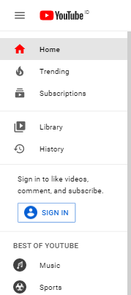

Figure 2. SideBar Example

1. **Search Page**
   * **Specifications**
   * After the search is **completed**, the user can filter by:
     + Upload date: **this week**, **this month**, and **this year**.
     + Type: **video**, **playlist**, and **channel**.
   * For each **video detail** use the **video display project requirement.**
   * For each **playlist** display **playlist thumbnail**, **playlist title**, **channel name**, **playlist short description**. Display the **play all button** to **start video** from the **first video** in the **playlist**. Display the **view playlist button** to redirect the user to the **playlist page** when clicked.
   * For each **channel** display **channel icon**, **channel name**, **channel subscriber**, **channel short description**, **channel video count,** and **subscribe button,** and if the user already subscribed display **bell button for notification**.

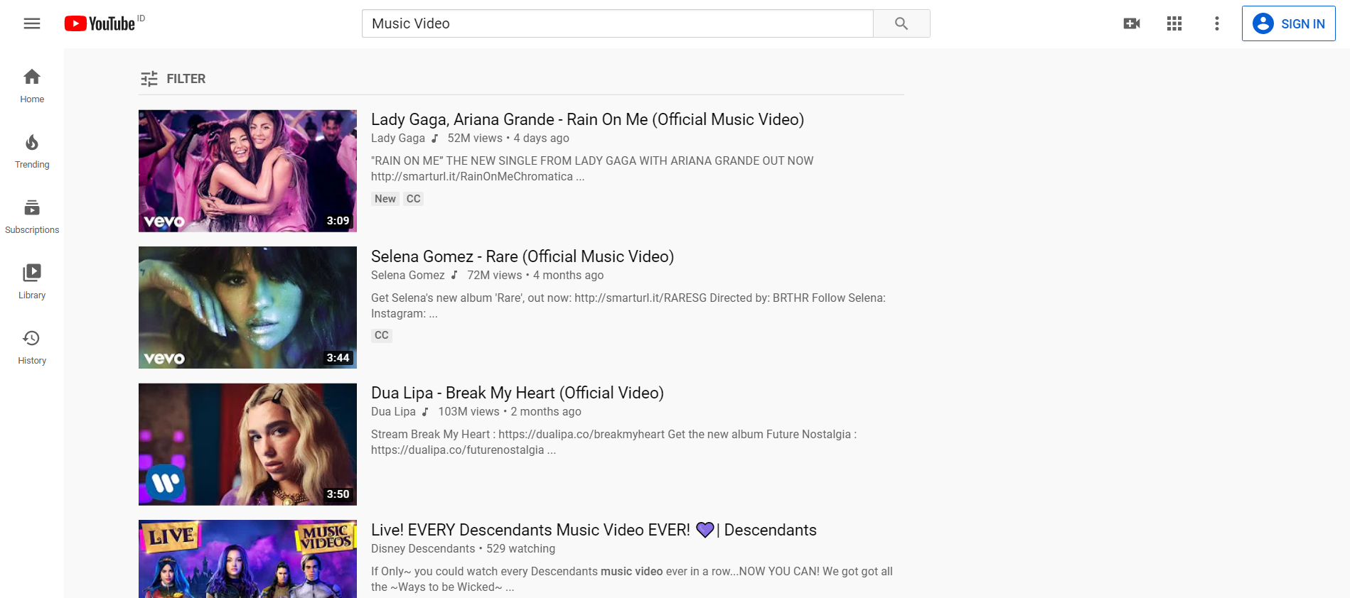

Figure 3. Search Page Example

1. **Home Page**
   * **Specifications**
   * Display **recommended videos**:
     + Display **random** video, but **prioritize** video based on **selected** **location** first then **other location**.
     + For each **video detail** use the **video display project requirement.**
   * To consider **the web performance** use **infinite scroll** when showing the videos.

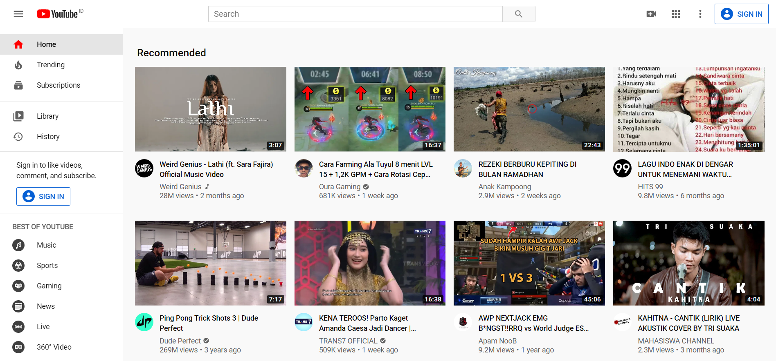

Figure 4. Home Page Example

1. **Trending Page**

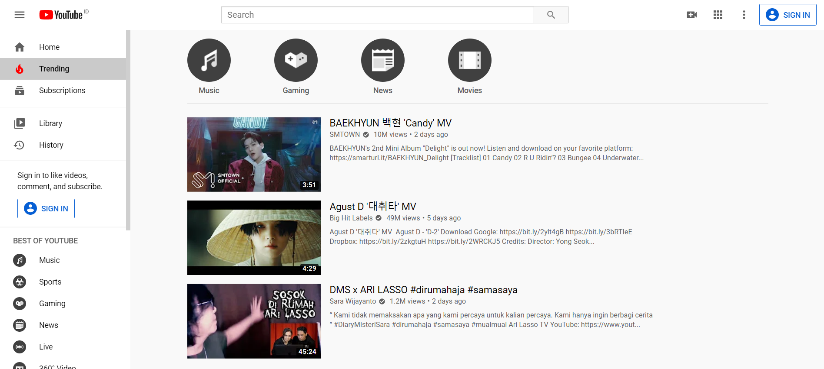

Figure 5. Trending Page Example

* + **Specifications**
  + Display **trending videos**:
    - Display up to **20 videos**, doesn’t need to use **infinite scroll** here.
    - Display all popular videos with range to **1 week before.**

ex: today: 18 June, 1 week before: 12 June, video range 12 June – 18 June

* + - **Sort** the displayed video from **the most viewed video** to **the least viewed video**.
    - For each **video detail** use the **video display project requirement.**

1. **Subscription Page (user only)**
   * **Specifications**
   * Validate **the** **user (guest)** already **logged in** if **not** ask the user to **sign in**.
   * Display **subscribed channel videos**:
     + **Sort** displayed video by **upload date**.
     + **Separate** displayed videos by **today**, **this week** and **this month**.
     + For each **video detail** use the **video display project requirement.**
   * To consider **the web performance** when showing the videosis displayed using **infinite scroll**.

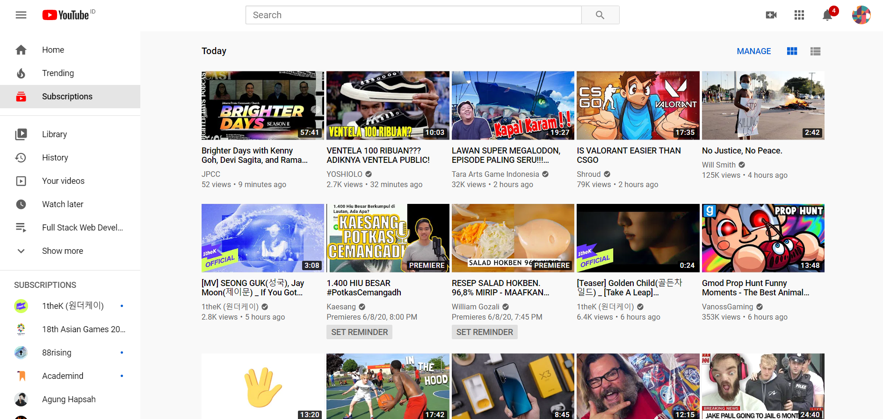

Figure 6. Subscription Page Example

1. **Playlist Page** 
   * **Specifications**
   * There are **2** **different types** of playlist:
     + **User** playlist
     + **Other users public** playlist
   * Here is the **user playlist** detail: **(user only)**
     + Show playlist detail:
       - Display **playlist** **thumbnail** based on the top video thumbnail in the list and **play button** to start from the first video.
       - Display **how many videos** in the **playlist**.
       - Display **when** the list is **last updated**.
       - Display **user profile** (**profile picture** and **profile name**), when clicked redirect to the **user channel page**.
       - Show how many **views** of **the playlist**, recorded from **how many times the video from that playlist played** not from the video’s total views.
       - For each **video** **detail** use the **video display project requirement.**
       - The user can also **remove a single video** from the list**.**
       - Display **sort view button**, when clicked user can change from **date added (old and new)**, **date published (old and new)**, **popularity(views)**.
       - **Custom sort** video list, user can change videos list order (ex: move a video to the top of the list).
       - The user can **move a video** to the **top list** or **bottom list**.
     + Display the **playlist’s title** and **edit title** **button**, when clicked user can **edit the playlist title**.
     + Display the **playlist’s description** and **edit description** **button**, when the button is **clicked**, the user can **edit the playlist description**.
     + User can also change **playlist privacy** (**private** or **public**)
     + Display **remove all videos button**, when clicked **remove all** the videos from the list.
     + Display the **shuffle play button**, when clicked **random play video** from the list.
     + If the playlist is public then display the **share button**, when clicked show **modal** to share **playlist URL** by **copy to clipboard** and **social media**.
   * Here is the **other user public playlist** detail:
     + Show playlist detail:
       - Display **playlist** **thumbnail** based on the top video thumbnail in the list and **play button** to start from the **first video**.
       - Display **how many videos** in the **playlist**.
       - Display **when** the list is **last updated**.
       - Show how many **views** of **the playlist**, recorded from **how many times the video from that playlist played** not from the video’s total views.
       - Display **user profile** (**profile picture** and **profile name**) with **subscribe button**, if subscribed shows **bell button** for **channel notification**
       - When the **user profile** is clicked redirect to the **user channel page**.
       - For each **video** **detail** use the **video display project requirement.**
     + Display the **shuffle play button**, when clicked **random play video** from the list.
     + The user can **add the playlist** to the playlist library or **remove** it from the library.
     + Display **share button**, when clicked show **modal** to share **playlist URL** by **copy to clipboard** and **social media**.
   * Other feature:
     + when loading video data keep in **mind the performance**, don't show all video data once for example **1000 videos in the playlist**, for this case **display the videos** using **infinite scroll**.

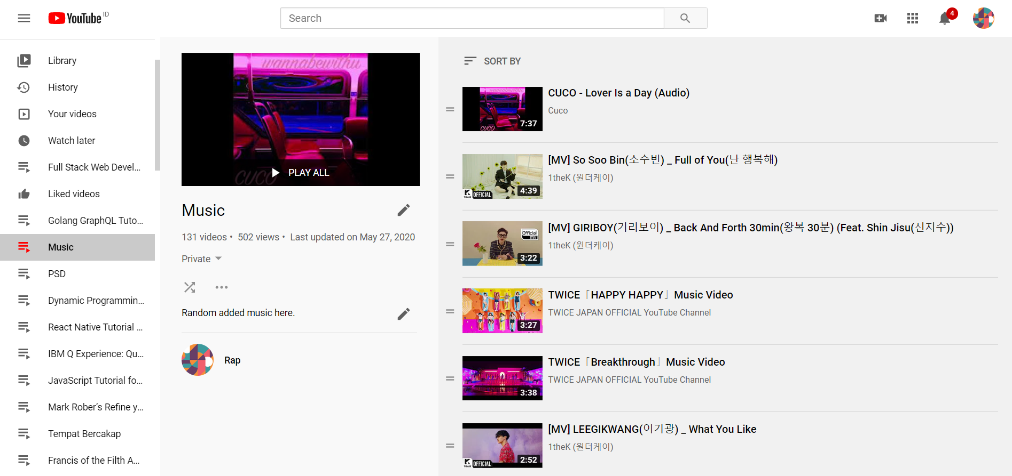

Figure 7. User Playlist Page Example

1. **Channel Page**
   * **Specifications**
   * Display **channel profile detail**
     + Display **channel icon** and **channel art/background**.
     + Display **channel name** and **subscriber count**.
     + if **subscribed**, show **subscribed button** and **bell for notification**.
     + if **not subscribed**, show the **subscribe button**.
   * Channel page detail:
     + Display tab view page for **channel home page**, **channel** **videos page**, **channel** **public** **playlist page**, **community page**, and **about page**.
     + Channel **home page**, divide the page into **3 different sections**:
       - Display **recently** **uploaded videos** and **see all video button**, when clicked move to **channel videos page.**
       - Display **5 random videos** and **see all video button**, when clicked move to **channel videos page**.
         * For each **video** **detail** use the **video display project requirement.**
       - Display **3 random playlists** and **see all playlist button**, when clicked move to **channel public playlist page**.
         * Playlist **detail**:

Playlist **title** and **thumbnail**.

Playlist **videos count**.

* + - Channel **videos page**:
      * The user can **sort** videos by **most popular**, **oldest**, and **newest.**
      * Display channel **videos** using **infinite scroll**.
      * If the user is **a** **premium member**:
        + Display **premium videos** with **a label / UI tag** to represent that the video is a **premium video**.
      * The user can sort videos by **most popular**, **oldest**, and **newest.**
      * For each **video** **detail** use the **video display project requirement.**
    - Channel **playlist page**:
      * Display channel public **playlist**.
      * Playlist **detail**:
        + Playlist **title** and **thumbnail**.
        + Playlist **videos count**.
    - Channel **community page**:
      * Channel’s owner can **post** something **with** or **without picture**.
      * Other user can **like** or **dislike posts**.
      * Post item contains **post’s date**, **like** and **dislike count.**
      * When post clicked redirect to **post detail page**.
    - Channel **about page**:
      * Display **channel description**.
      * Display **channel stats**: **join date** and **views count**.
      * Display **shared links**, user can see the channel shareable link to their **social media** or **website.**
  + Your channel page:
    - The user can change the **channel icon** and **channel** **art/background**.
    - Edit channel about us page (**description** and **shareable** **links**).
    - Change video **privacy** (**public** or **private**).
    - **Delete video** from the channel.
    - Edit video detail: **description**, **title**, and **thumbnail**.

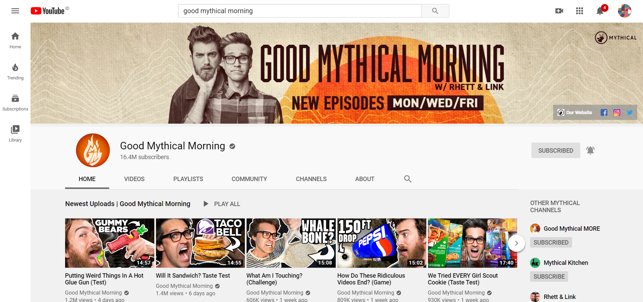

Figure 8. Channel Page Example

1. **Category Page**
   * **Specifications**
   * Category list **needs to be added**:
     + Music
     + Sport
     + Gaming
     + Entertainment
     + News
     + Travel
   * You can add more categories to diverse video more (**optional**).
   * Category page detail:
     + Display a list of videos **according to the category**.
     + Display video will be divided into 4 different sections **all-time popular**, **popular this week**, **popular of the month**, and **recently uploaded.**
     + Display up to **20 videos**, doesn’t need to use **infinite scroll** here.
     + For each **video** **detail** use the **video display project requirement.**

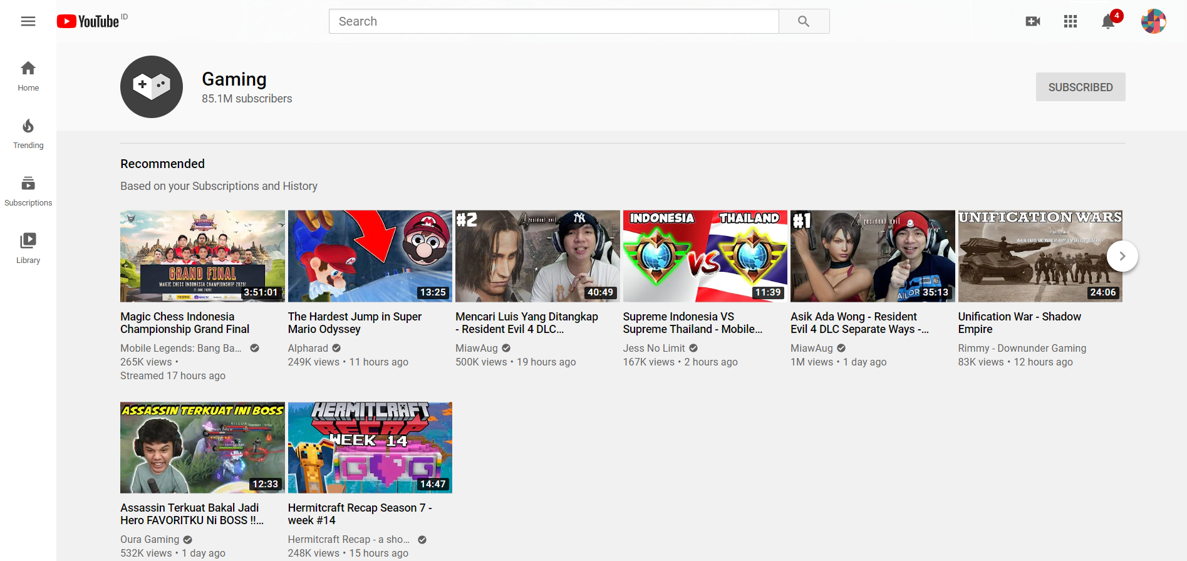

Figure 9. Category Page

1. **Premium membership page**
   * **Specifications**
   * Not a premium member:
     + Display what **premium membership** offers:
       - View **premium videos**.
       - View **not yet published** or **scheduled** videos.
       - **Download** videos.
     + Display billing detail plans to choose (**monthly** or **annually**).
     + Display **register premium button**, when the button is **clicked**, user can gain premium membership according to their chosen **billing plan.**
   * Premium member:
     + Display what **premium membership** offers:
       - View **premium videos**.
       - View **not yet published** or **scheduled videos**.
       - **Download** videos.
     + Display **premium** **membership history** and **billing detail**.
     + Display the **premium** **membership expiration date** until the **next payment**.

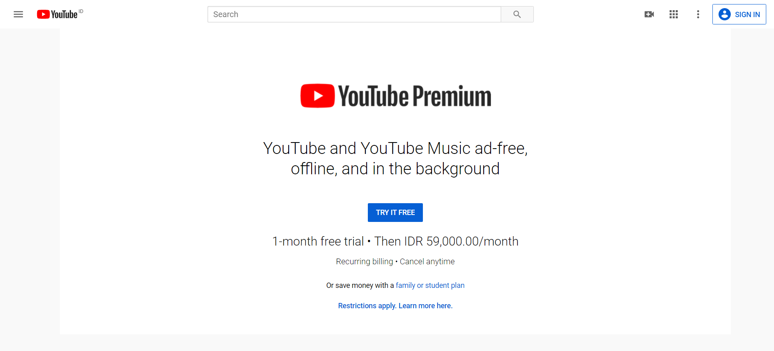

Figure 10. Premium Membership Page

1. **Video Detail Page**
   * **Specifications**
   * Divided into 4 sections:
     + Video player section
     + Video detail description section
     + Video comment section
     + Related video section
   * **Video player** section:
     + Display **play** or **pause button**
     + Display player **time** **stamp** and **length**.
     + Display player **sound slider** to change **video volume**.
     + Display the **mute button**, when clicked **mute** or **unmute video**.
     + Display **next button**, when clicked **play the next video** in **related video list**, if the video is played from **playlist** or **queue** play next from **playlist** or **queue**.
     + Display the **video quality button**, when the button is **clicked**, the user can change **video quality** relative to the **user screen**.
     + Display **fullscreen button**, when the button is **clicked**, set video to **fullscreen mode**.
   * **Video detail description** section
     + Display **video title**, **uploaded date**, and **video’s views count**.
     + Display **like** and **dislike button** with **count** (count in **metric format**), when clicked user can **like** or **dislike the video**.
     + Display **like** and **dislike ratio** using a **slider percentage**, when **hovered** show **like** and **dislike count**.
     + Display **share button**, when clicked show **modal** to share **video URL** by **copy to clipboard**, **copy to clipboard** with current **time played** and **social media**.
     + Display **channel icon**, **name**, and **subscriber count**.
     + Display **subscribe button**, if subscribed show **bell button** for **channel notification.**
     + Display **save to playlist button**, when clicked show **modal** to **add video** to **selected playlist**.
     + Display video **description**, **category,** and **tag**.
   * **Video comment** section:
     + Display **all comment** using **infinite scroll**.
     + Display **comment count**.
     + The user can **sort** comments by **top liked comment** or **newest**.
     + Display **insert comment section** so the user can comment on the video.
     + comment display detail:
       - Display **user name**, **icon,** and **comment date**.
       - Display **comment description**.
       - Display **like** and **dislike button** with **the** **count**, when clicked user can **like** or **dislike comment**.
       - Display **reply button**, when the button is **clicked**, user can **give a reply to comment**.
       - Display **reply count** ifthe comment had been replied.
       - Display dropdown to **show** and **hide** all replies.
       - Reply can also be **replied**.
   * **Related video** section:
     + Display **playlist** or **queue** if the video is played from the **playlist** or **queue**.
     + Display **autoplay toggle button**, when enabled after video **finishes playing**, **play the next video** in **related video** list, if the video is played from **playlist** or **queue** play next from **playlist** or **queue**.
     + The **related video** is displayed from **category** and **location** **related** to the video **currently playing**.
     + Display **related video** using **infinite scroll**.
     + For each **video detail** use the **video display project requirement.**
   * **Keyboard shortcut**:

using the utilize button for shortcut user can easily **change the video option**, please assign these keys for the specific action:

* + - **j - backward 10 second**
    - **k - play or pause video**
    - **l - forward 10 second**
    - **f - fullscreen mode**
    - **↑ - up the video volume**
    - **↓ - low the video volume**
    - **Right-click** on **video player – display options:**
      * **Loop – loop video.**
      * **Copy link,** copy video URL to the **clipboard.**
      * **Copy link** with **the current time**,copy video URL to the **clipboard** with the **current time.**

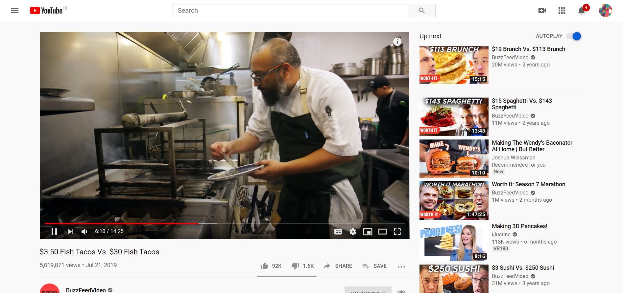

Figure . Video Detail Page

1. **Upload video**

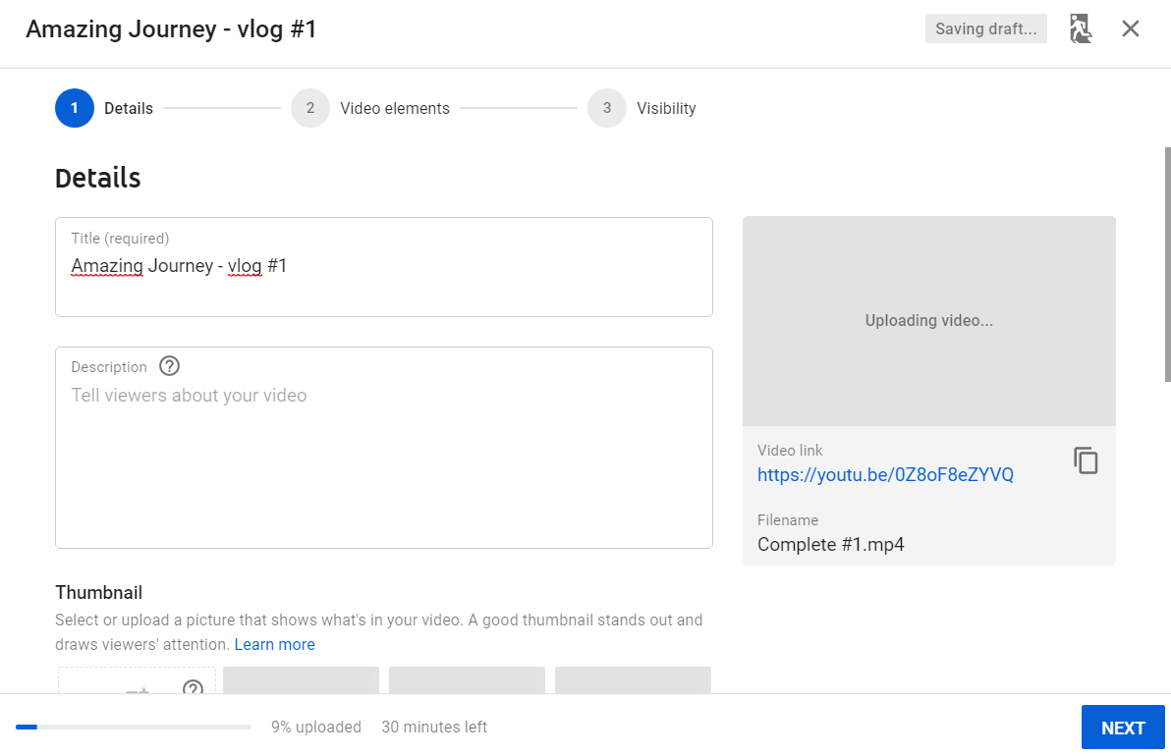

Figure 12. Upload Video Page

* + **Specifications**
  + Divided into **3 sections**:
    - **Select the video** section:
      * The user can **select a video** to be **uploaded**.
      * The user can **drag and drop** a video to **upload video section**.
    - **Video detail** section:
      * The user can input **video title**, **video description, video category**, and **upload** **video thumbnail**.
      * The user can also **add the uploaded video** to **a** **playlist**, if they want to add to a playlist, **ask the user** where they want to **save the video** to which **user-created playlist only**.If there is no **user-created playlist** than the user can create a new playlist by clicking the **new playlist** **button**.
      * The user can also set the **age restriction (**video with **restriction** only **viewable by the user** with **age more** than **18 years old)** of the video to filter **the video preference**.
    - **Visibility setting** section:
      * The user can set the **video privacy** (**public** or **private**)
      * The user can set the **video** **schedule DateTime** to be **published**.
  + While **uploading video** and **set the video option** user can also see the progress on the side view:
    - Display **video title** and **description**.
    - Display **video** **thumbnail**, **length**, and **link**.

1. **Video Display Project Requirement**
   * **Specifications**
   * Display detail for every video on the **list**:
     + For each video show **video detail**: **video** **thumbnail**, **video** **title**, **video** **length/duration**, **channel**, **views** (shown in the **metric format**, ex: 1540 = 1.5k),and **date uploaded** in a human-readable format.
     + Display **setting button**, when clicked display **add to queue** and **add to** **playlist** (signed in user only):
       - When **add to queue button** is clicked, add video to **queue** and **auto-play** video. If there is no queue yet, then create a **new queue**.
       - When **add to playlist** **button** is clicked, display **modal** that will ask to save the video to which **user-created playlist only** if there is no **user-created playlist** than the user can create a new playlist by clicking **new playlist** **button** on the modal.

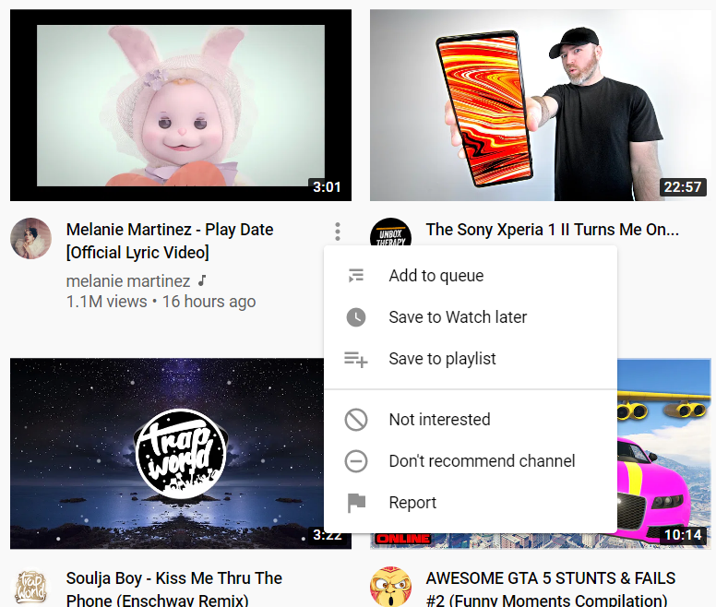

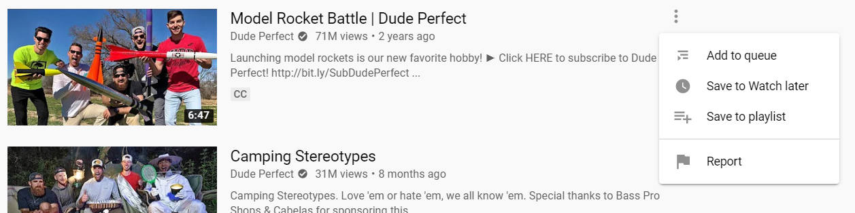

Figure 13.Video Detail Project Requirement Example